Instructions for Ethereum prototype:

1)Download the [eth.build (5).webloc](https://github.com/u3572069/Rakathon_2021_SupplyEasy/blob/main/eth.build%20(5).webloc) file

2) Visit sandbox.eth.build

3) 

Access the highlighted load button and upload the **eth.build (5).webloc** file

 from this button

4) A page like stated below will appear

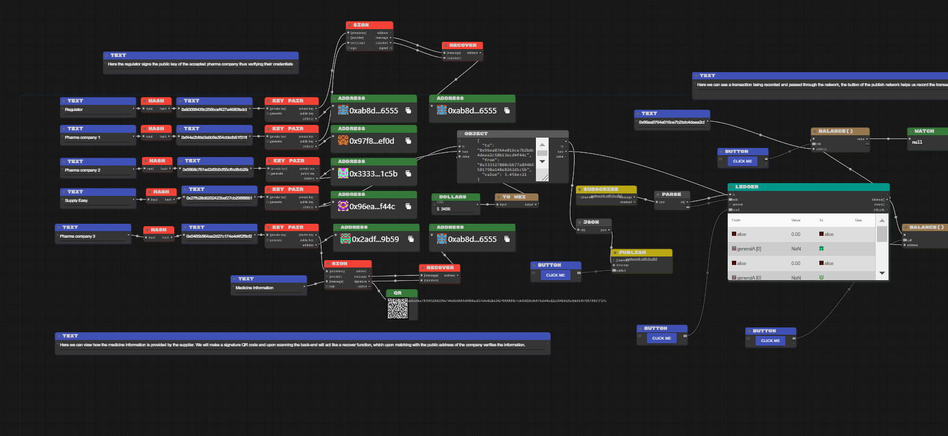

You can view the different parts we’ve implemented

5) In the topmost part is the regulator which signs the public key of the pharma company 1, thus verifying their credentials and allowing them to join our consortium

6) In the bottom half pharma company 3, signs medicine information using their private key, and the resultant QR code gives their signature, which can be verified at the back-end with the medicine information (depicted by the recover block) hence eliminating counterfeiting.

7) A transaction can also be seen going through the Ethereum network between pharmaceutical company 2 and SupplyEasy, and being recorded in the ledger

A transaction can be simulated using the button connected to the **publish** block.